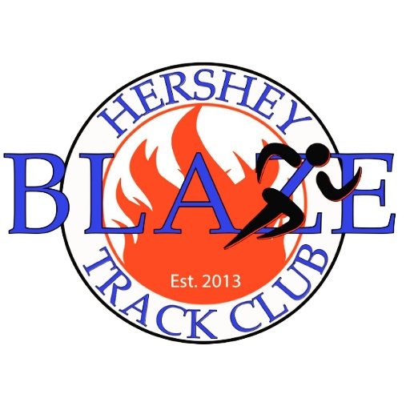

Hershey Blaze Track Club
USATF CLUB # 08-0462/ AAU Club #WYTE75
PO Box 46 Hershey, PA 17033
www.hersheyblazetc.org
2019 MEMBERSHIP REGISTRATION
Please check lines where appropriate below
Returning Blaze Athlete________ First-Time Athlete_________
Winter Training/ Indoor Season________ Outdoor Season_________ Cross Country Season________
Preferred Blaze Training Site: Hershey____ King of Prussia_____ Berks______ Mechanicsburg____
Name______________________________ ___________________________________
(last) (first)
Address____________________________________City_______________State______Zip__________
Home Phone__________________ Parent(s) Cell Phone_____________________/________________
Sex/ Gender________Age___________(as of December 31st of the current year)
Date of Birth_____________________
Parent/ Guardian Name(s) _______________________________ Parent(s)Email____________________/_______________________
Member's Email_______________________
Please List Any Physical Handicaps, Injuries,Allergies_________________________________________
Date of Athlete’s Last Physical ______________Grade and School Attending______________________
============================================================================
As the parent or legal guardian of the above athlete _____________________________________, I fully
understand that participation in athletics, in this case track and field, could result in both minor and serious injury and even death. I further understand that to minimize the risk of injury or harm, the athlete should have had a physical within the past year. I assume any and all risks associated with the above athlete’s participation as a member of the Hershey Blaze Track Club and I hereby waive and release the Hershey Blaze Track Club, its coaches and representatives, of any and all rights for damages or injuries suffered while participating with the Hershey Blaze Track Club during a scheduled practice, conditioning session or competition; while traveling to or from a scheduled practice, conditioning session or competition; or during any other club related activity.

Parent or Guardian Signature
___________________________________________Date_____________________
Parent or Guardian Signature
___________________________________________Date_____________________
Athlete Signature
___________________________________________Date_____________________

